API Documentation Screenshots

Test 1
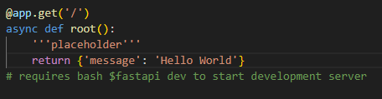
Initial display based on first test code entry above, using http://127.0.0.1:8000
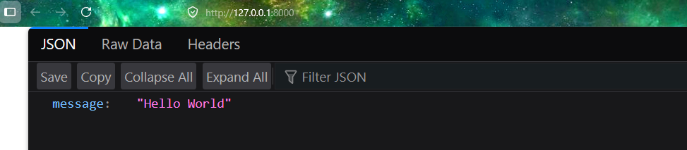

Test 2
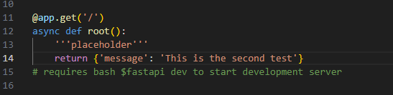
Second display based on new test code entry above, using http://127.0.0.1:8000
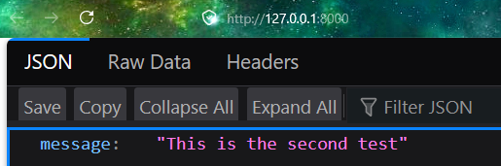

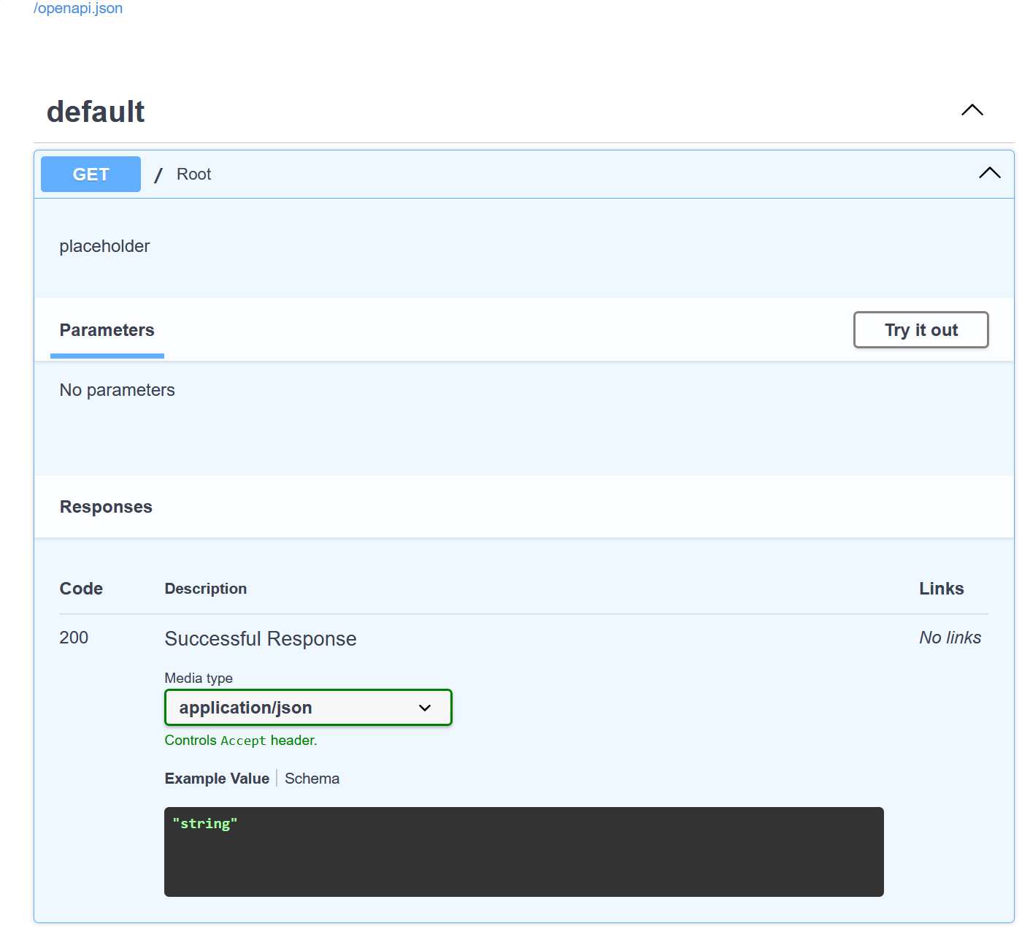
http://127.0.0.1:8000/docs - automatic API documentation
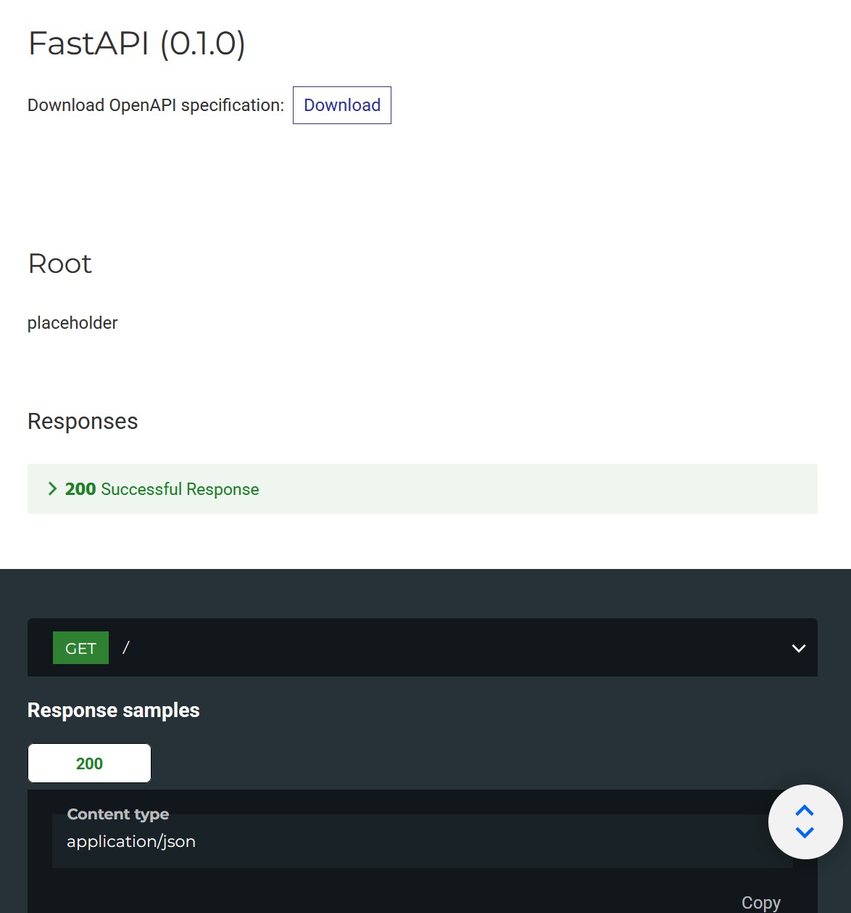
http://127.0.0.1:8000/redoc - Alternative documentation
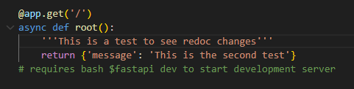

By making changes to the function docustring, it changes the ROOT description in the redoc page.
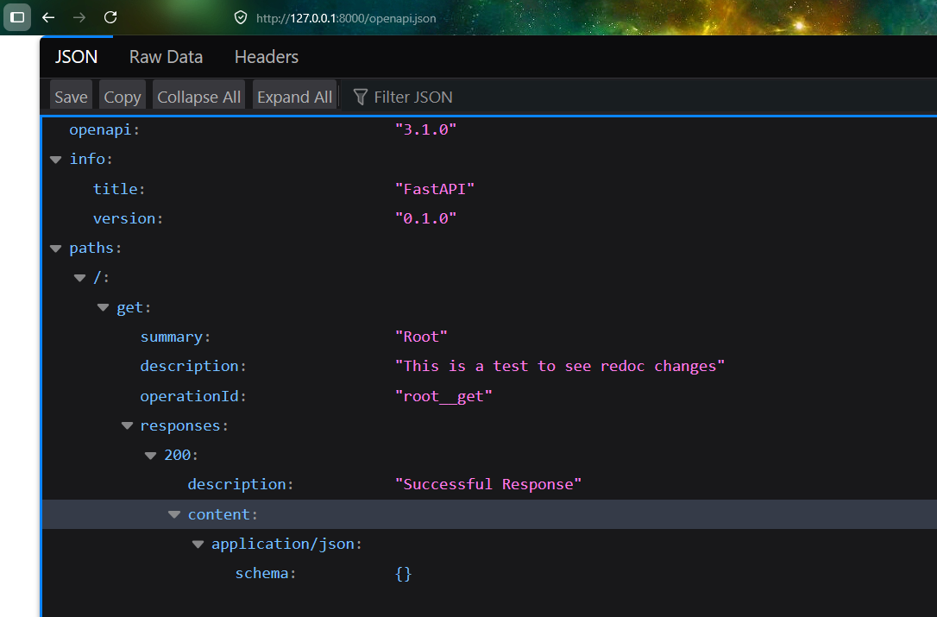
The raw OpenAPI schema using http://127.0.0.1:8000/openapi.json

